LAB 3 – IDEATION & PROTOTYPING
Roll no.: 24BTCE235
Name: Ananth.S

Topic: Uneven Distribution of Internships in India
Context:
In India, internship opportunities are not equally distributed among students. Students from metro cities, private institutions, and technical backgrounds often receive more internship exposure compared to students from rural areas, government colleges, or non-technical courses. This lab focuses on ideating and proposing solutions to reduce internship inequality.

STEP1: Problem Statement
Many students in India do not get equal access to internship opportunities due to location, institutional bias, lack of awareness, skill gaps, and limited industry connections.

STEP 2: Define the Target User
Primary Users:
- Final year undergraduate students
- Students from Tier-2 / Tier-3 cities
- Government college students
- Students with limited industry exposure

STEP 3: Empathy Phase
Key Insights Identified:
1. Students lack awareness of internship platforms.
2. Many rely only on college placement cells.
3. Rural students face communication barriers.
4. Companies prefer students from reputed institutions.
5. Students feel discouraged due to repeated rejection.

User 1
Name: Abdulla Irshad.
Age:21
Occupation: student.

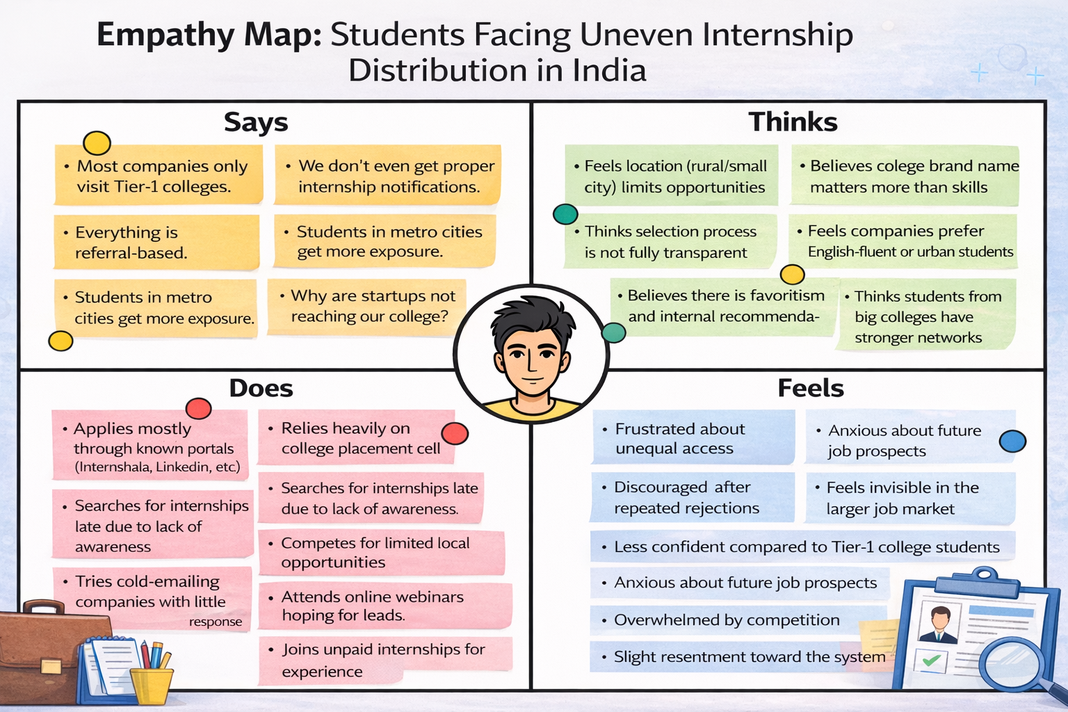
User 2
Name: Vedank Srivastava.
Age:22.
Occupation: Intern/Student.

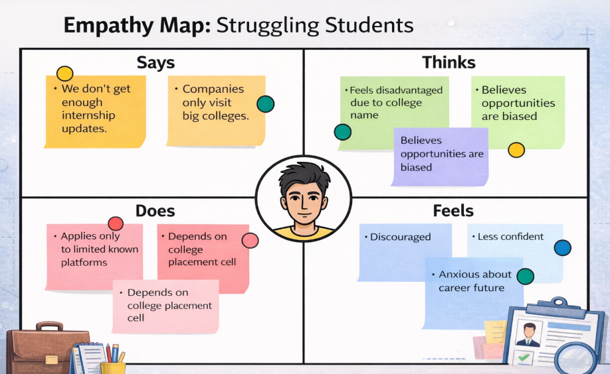

STEP 4: How Might We (HMW) Questions
1. How might we make internship opportunities accessible to students in rural areas?
2. How might we create a transparent internship allocation system?
3. How might we connect small companies with deserving students nationwide?
4. How might we increase awareness and skill readiness among students?

STEP 5: Brainstorming Ideas
Idea 1: Centralized Internship Portal for All Colleges
Idea 2: AI-based Matching System
Idea 3: Internship Awareness Workshops in Rural Colleges
Idea 4: Skill Certification Programs Before Internship Matching
Idea 5: Government-Supported Internship Equity Scheme

STEP 6: Select the Best Solution
Selected Solution:
Development of a Centralized Internship Equity Platform with AI-based matching to ensure fair opportunity distribution across institutions and locations.

STEP 7: Prototype Planning
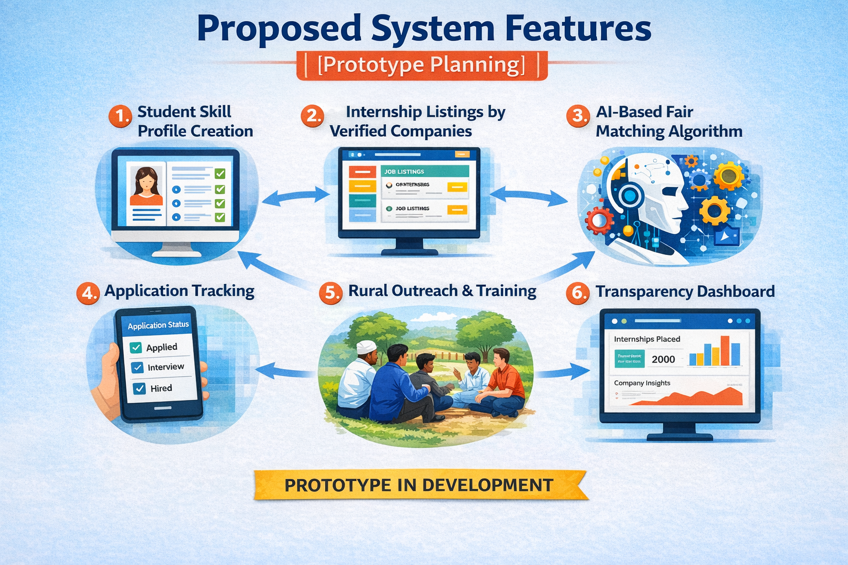
FLOWCHART
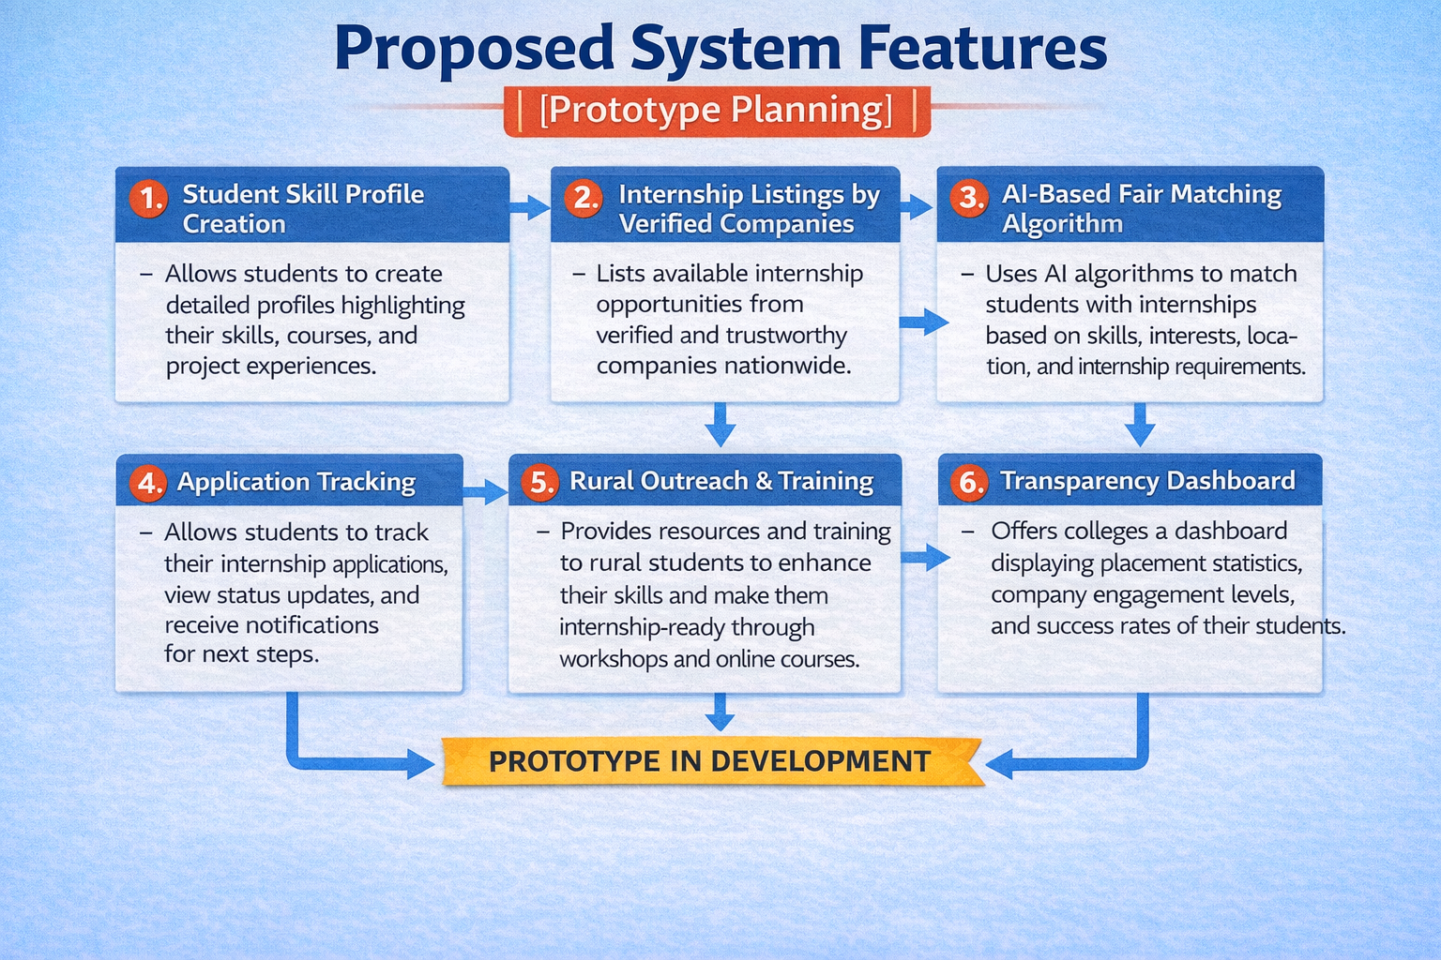
Feature 1: Student Skill Profile Creation
Feature 2: Internship Opportunity Listing by Verified Companies
Feature 3: AI-Based Fair Matching Algorithm
Feature 4: Internship Application Tracking
Feature 5: Rural Outreach & Training Section
Feature 6: Transparency Dashboard for Colleges

STEP 8: Low-Fidelity Prototype Description
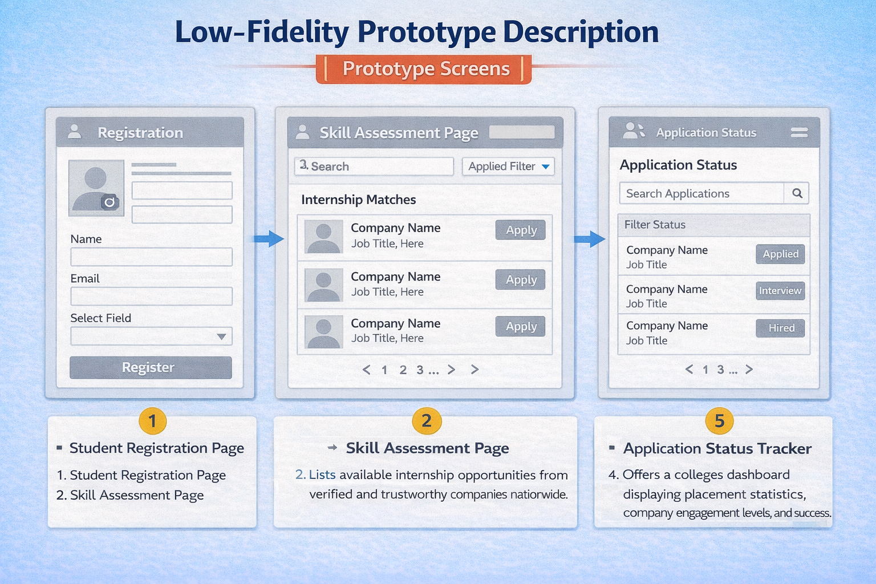
Prototype Screens:
1. Student Registration Page
2. Skill Assessment Page
3. Internship Matching Dashboard
4. Application Status Tracker
5. Feedback & Rating System
STEP 9: User Feedback
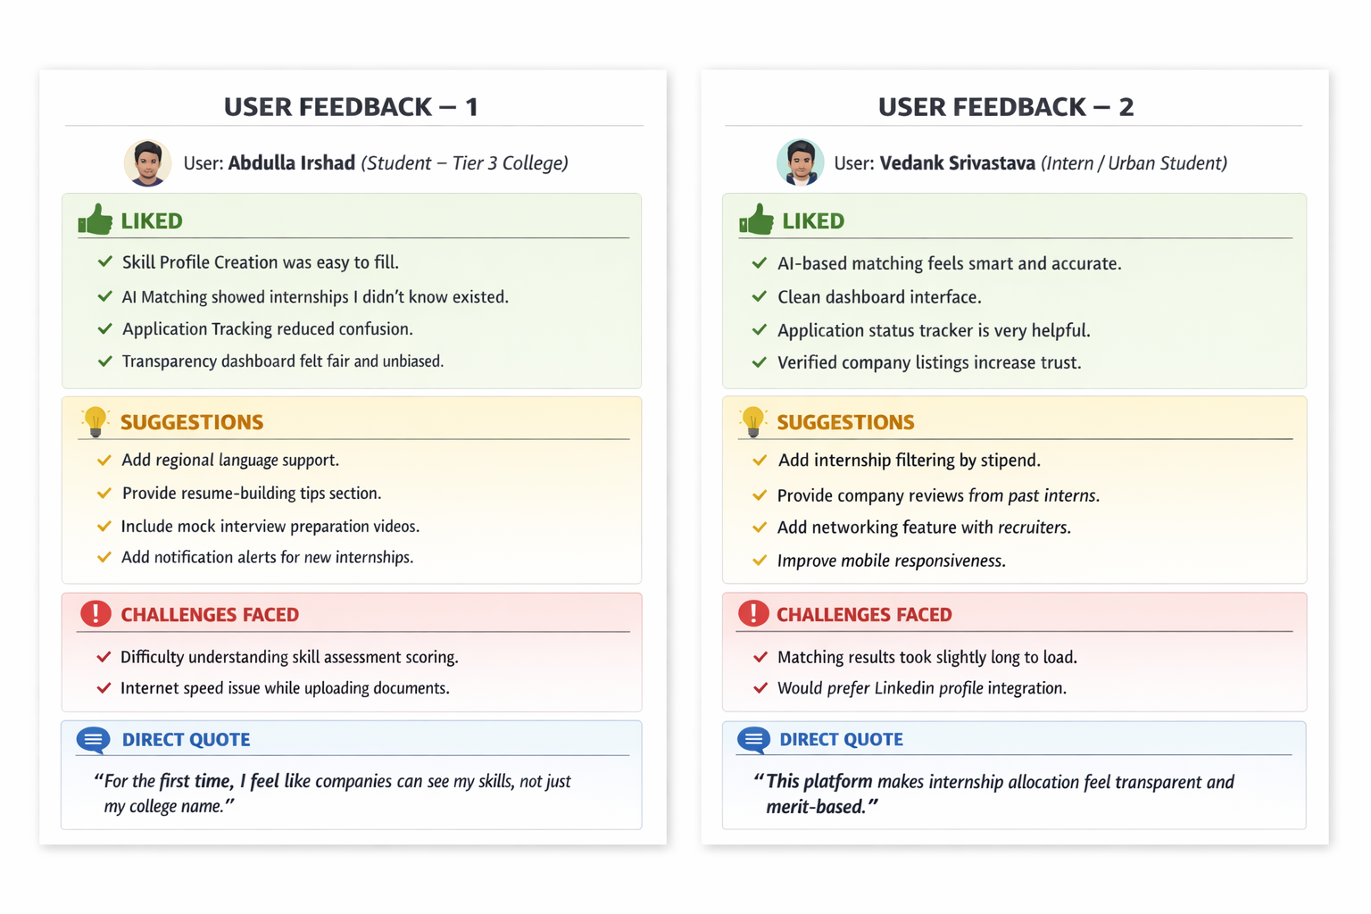

STEP 10: Expected Impact
- Equal access to internship opportunities
- Increased transparency in internship allocation
- Better industry-student connection
- Reduced regional and institutional bias
- Improved student confidence and employability

STEP 11: Reflection
This lab helped in understanding that internship inequality is not only a placement issue but a systemic accessibility problem. Ideating solutions highlighted the importance of technology, transparency, and outreach in reducing opportunity gaps. The design thinking process enabled structured problem-solving and solution planning.

